Contents

Array 3

560. Subarray Sum Equals K 3

1. Two Sums: 4

523. Continuous Subarray Sum 5

31. Next Permutation 6

670. Maximum Swap 6

56. Merge Intervals 7

986. Interval List Intersections 8

88. Merge Sorted Array 10

347. Top K Frequent elements 11

215. Kth largest Element in an Array 11

713. subarray product less than k 12

162. Find Peak Element 13

71. Simplify Path 14

238.Product of Array Except Self 15

973.K Closest Points to Origin 16

1570. Dot Product of Two Sparse Vectors 17

1762. Buildings with an Ocean view 18

1891. Curring Ribbons 19

String 20

953. Verifying an Alien Dictionary 20

249. Group Shifted Strings 20

249. Group Shifted String 21

1249. Minimum Remove to Make Valid Parentheses 22

921. Minimum Add to make Parenthese Valid 23

125. Valid Palindrome 24

680. Valid Palindrome II 24

227. Basic Calculator II 25

408. Valid Word Abbreviation 25

415. Add Strings 26

791. Custom Sort String 26

246. Strobogrammatic Number 27

Binary Trees 28

314. Binary Tree Vertical Order Traversal 28

1650. Lowest Common Ancestor of a Binary Tree III 29

938. Range Sum of BST 29

236. Lowest Common Ancestor of a Binary Tree 30

199. Binary Tree Right Side View 31

543. Diameter of Binary Tree 32

270. Closest Binary Search Tree Value 33

Depth First Search and Breath First Search 34

721. Accounts Merge 34

Structure Design and Linked List 35

146. LRU Cache 35

234. Palindrome Linked List 37

346. Moving Average from Data Stream 38

1570. Dot product of two sparse vectors 39

Matrix 40

766. Teoplitz Matrix 40

498. Diagonal Traverse 41

1091. Shortest Path in Binary Matrix 41

Recursion: 42

339. Nested List Weight Sum 42

50. Pow(x,n) 42

# Array

## 560. Subarray Sum Equals K

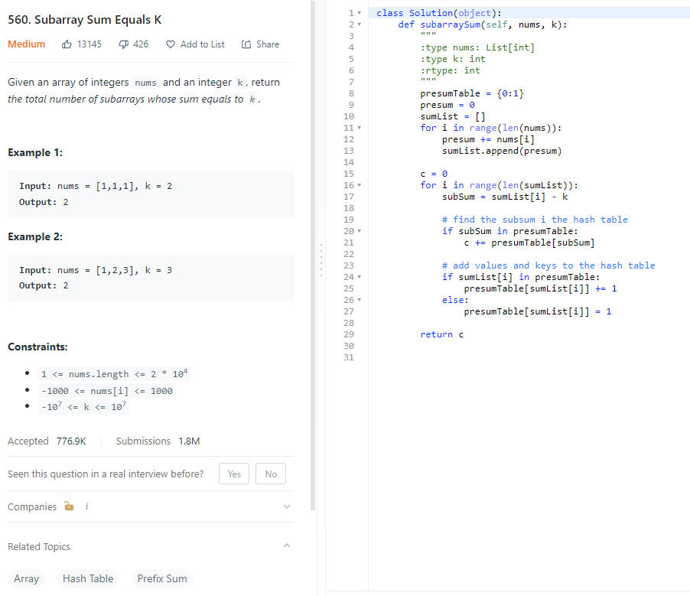

Time: O(n), only traversed the list once

Space: O(n), extra space for the hashtable

## Two Sums:

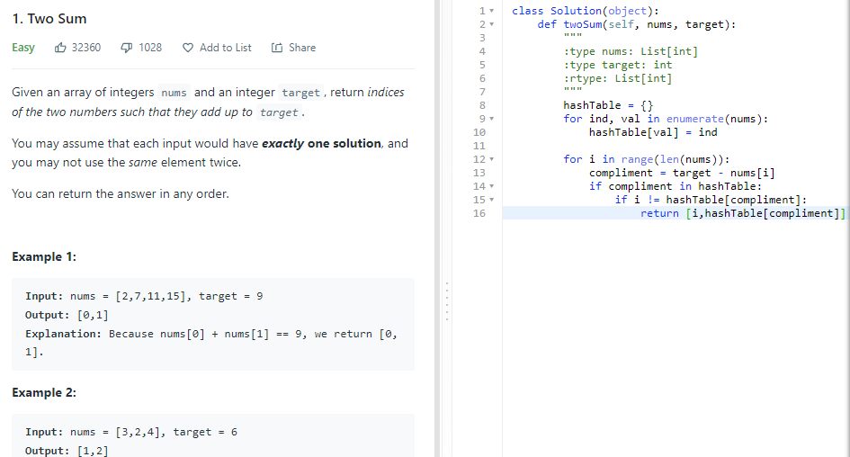

Optimized

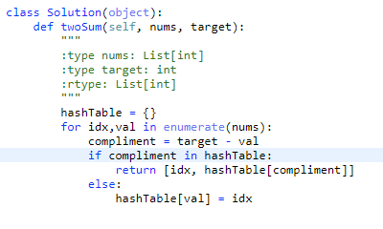

Brute Force

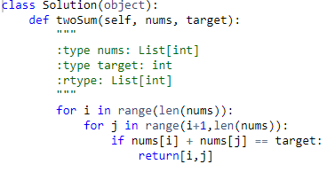

## 523. Continuous Subarray Sum

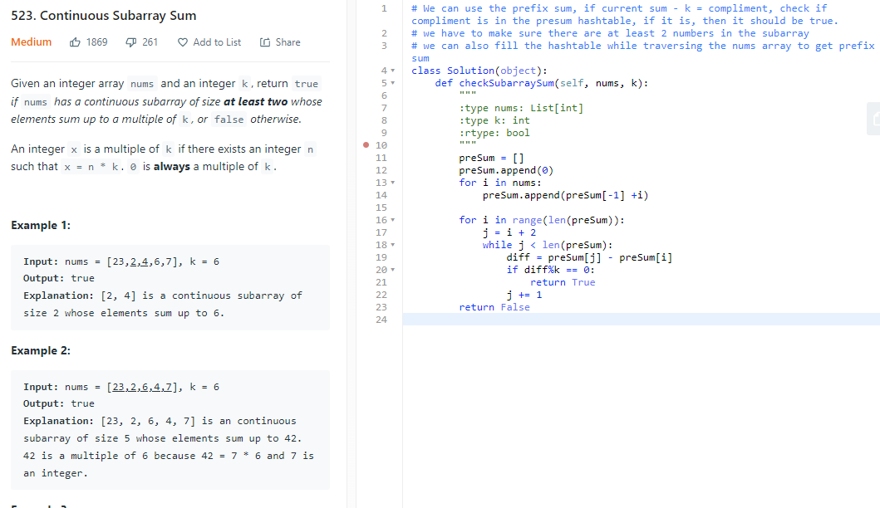

Brute force:

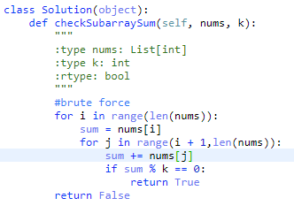

Time: O(n2)

See next page for best solution

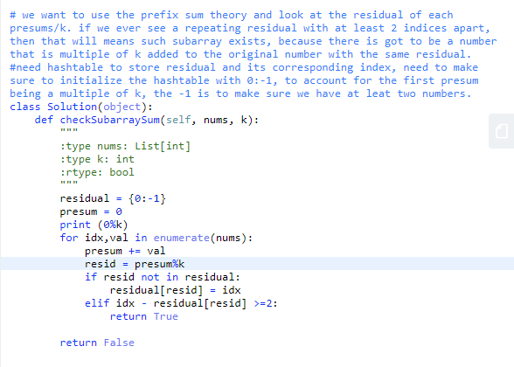

Time:O(n)

Space: O(n)

## 31. Next Permutation

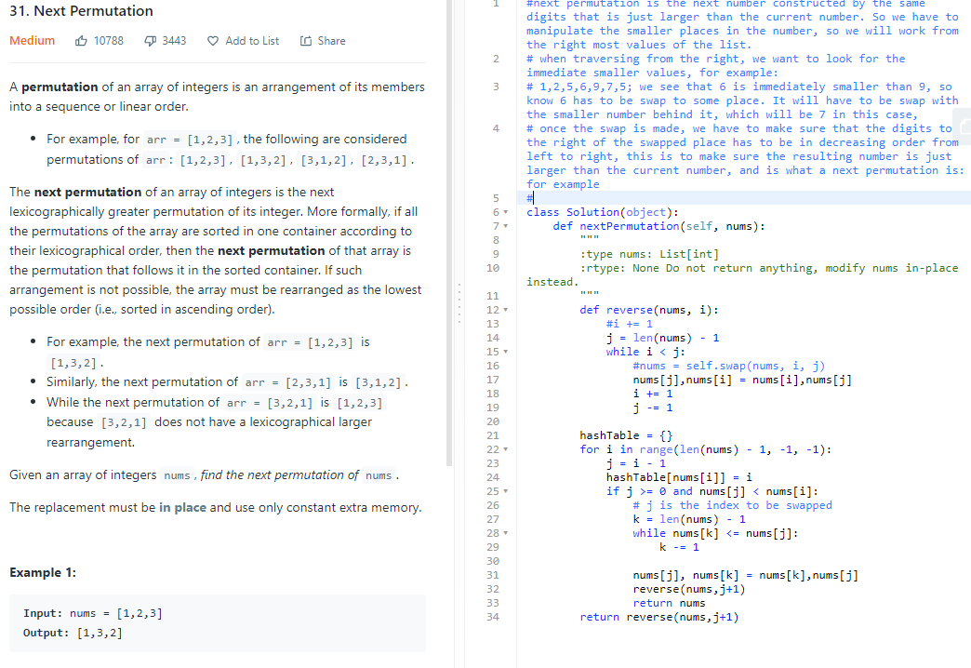

## 670. Maximum Swap

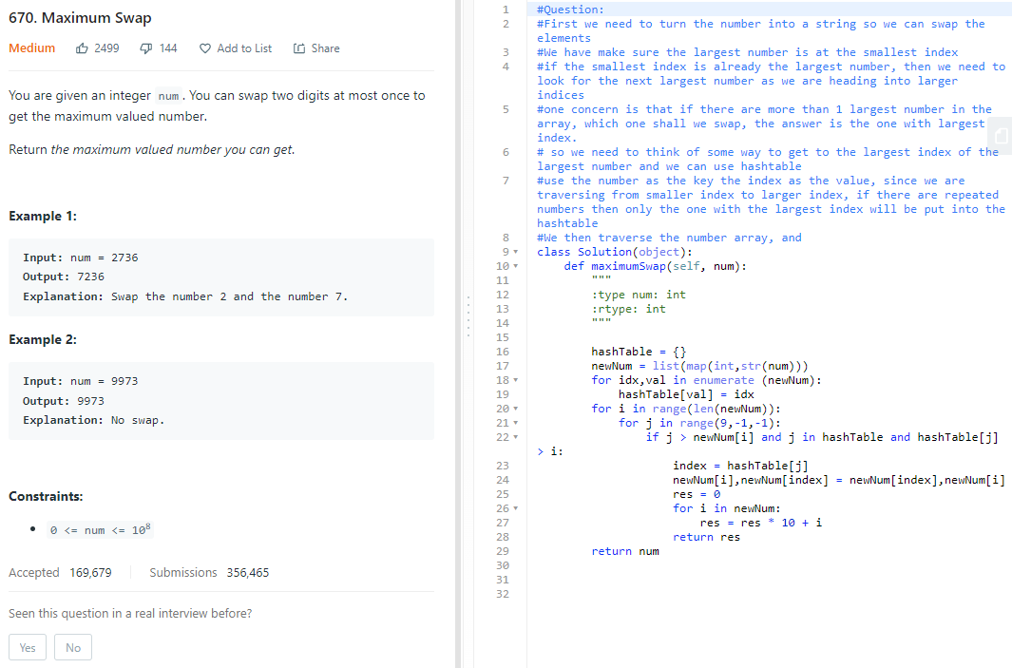

## 56. Merge Intervals

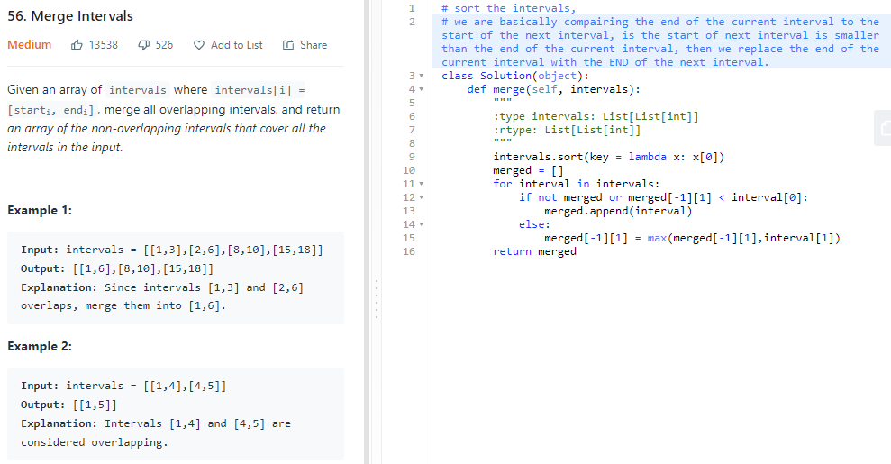

## 986. Interval List Intersections

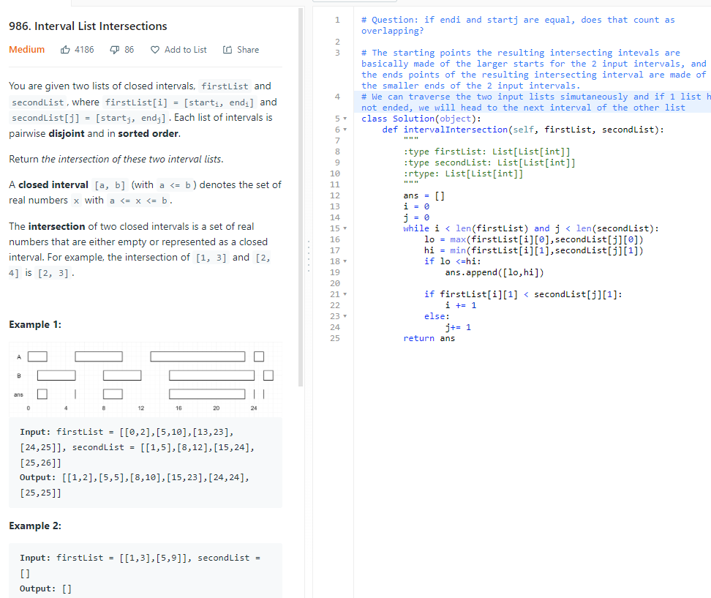

## 88. Merge Sorted Array

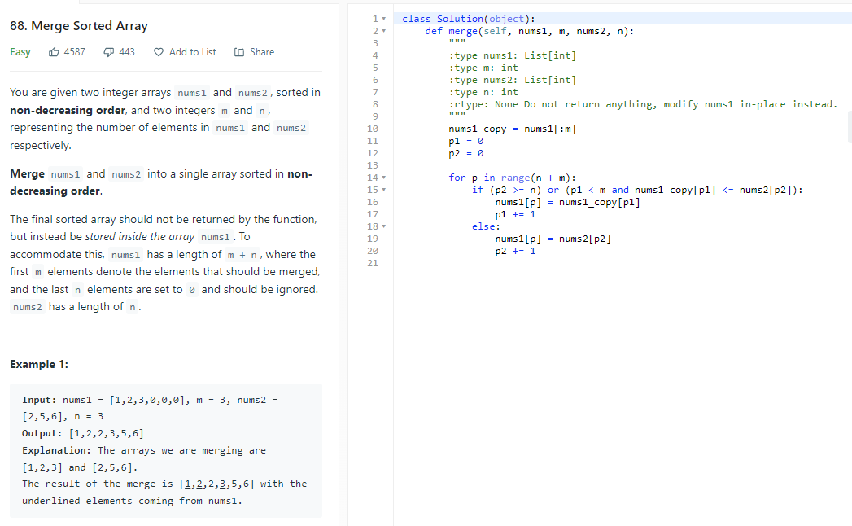

## 347. Top K Frequent elements

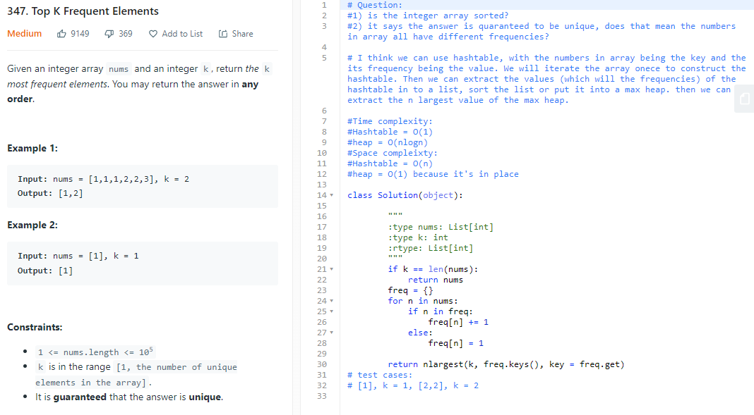

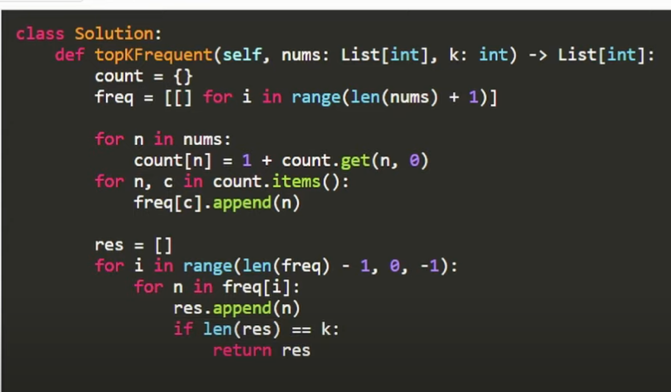

## 215. Kth largest Element in an Array

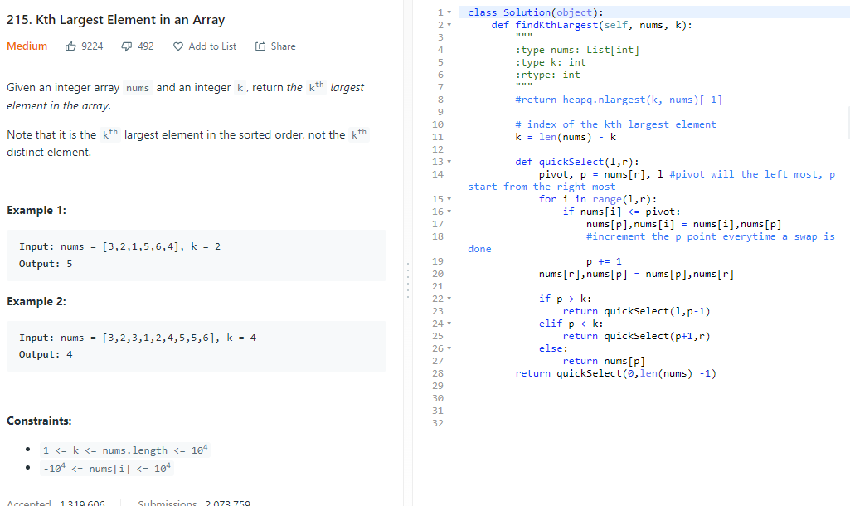

Time: Average O(n), worst O(n2)

Space: O(n), recursive

## 713. subarray product less than k

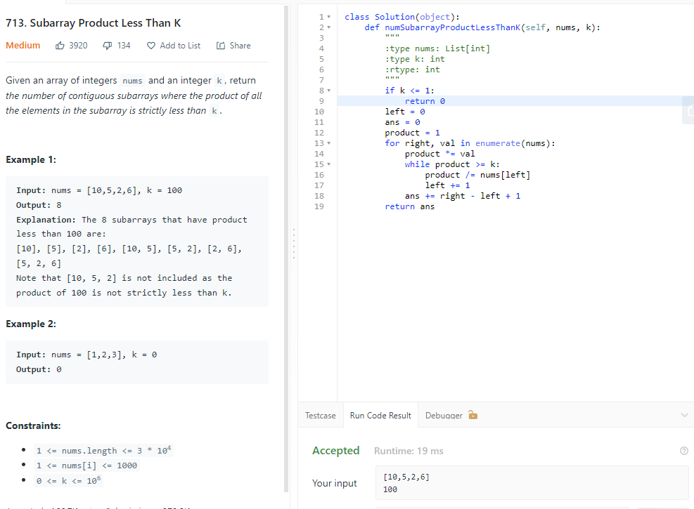

## 162. Find Peak Element

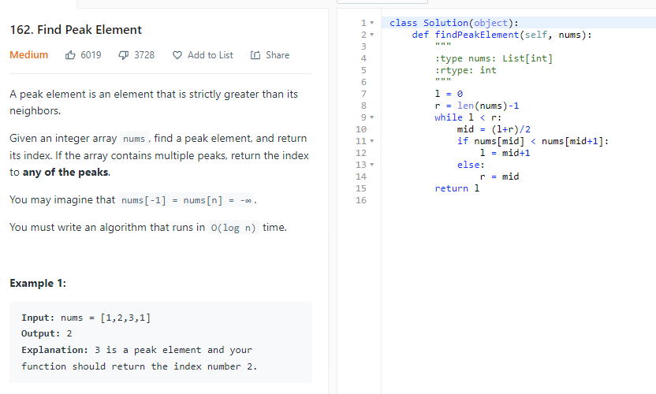

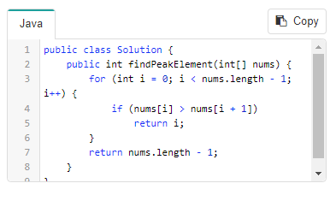

## 71. Simplify Path

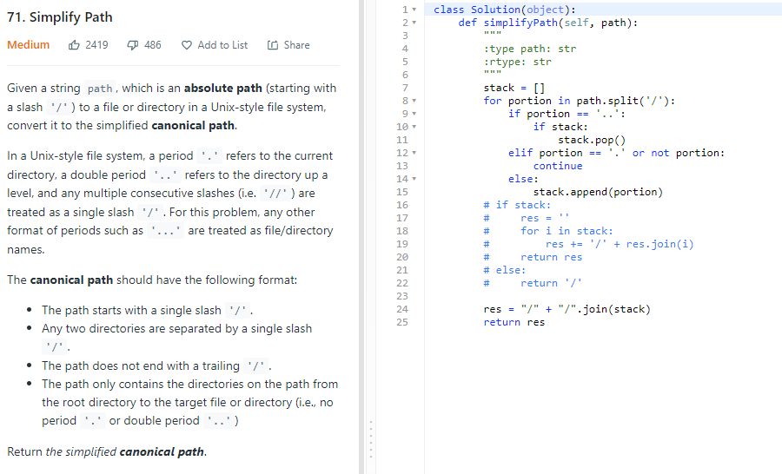

Time: O(n)

Space: O(n)

## 238.Product of Array Except Self

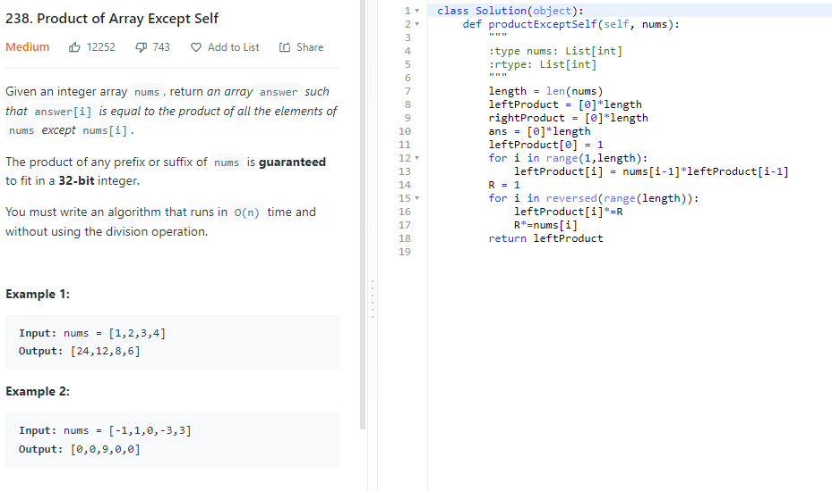

## 973.K Closest Points to Origin

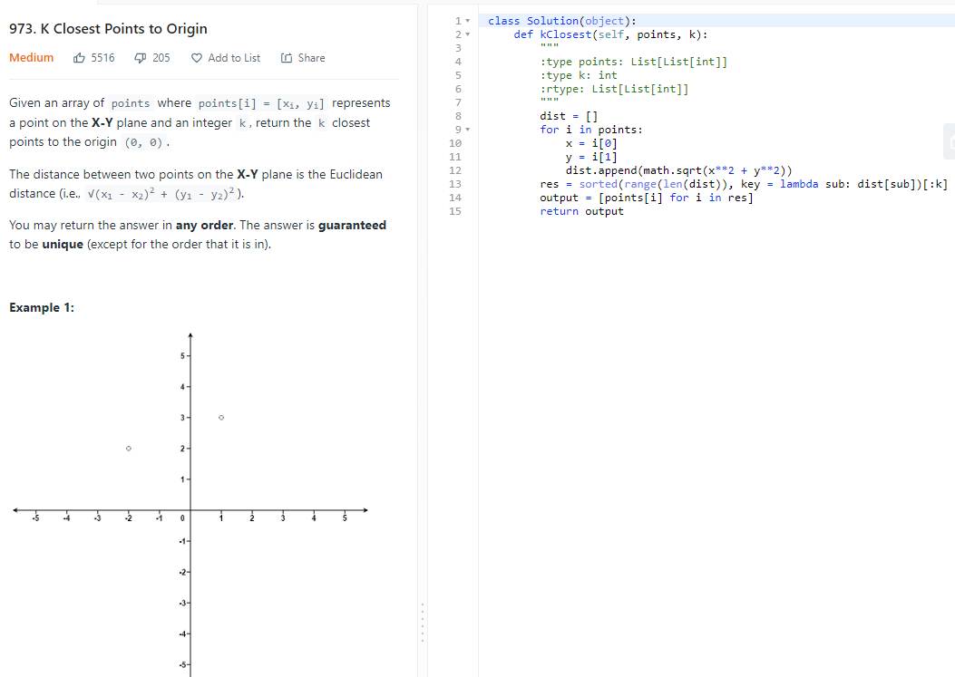

## 1570. Dot Product of Two Sparse Vectors

2 pointers

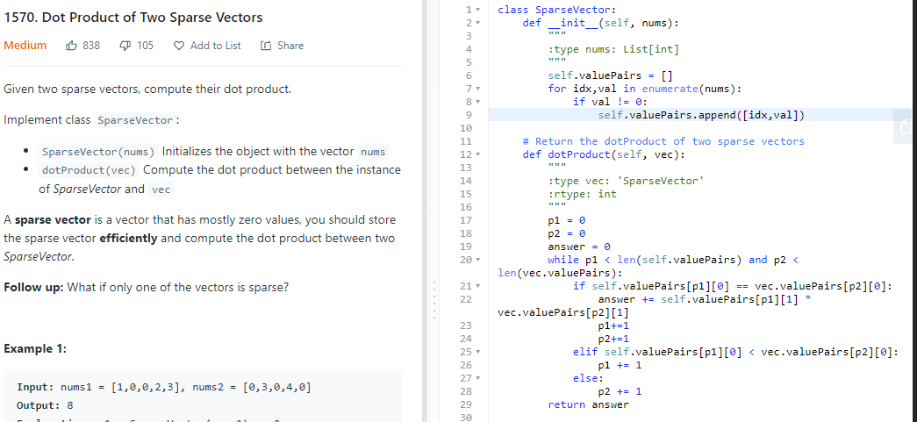

Time: max(O(n),O(v)), v is the number of non-zero items, O(v) is for calculation of dot products

Space: O(L), L is the number of nonzero items

HashMap:

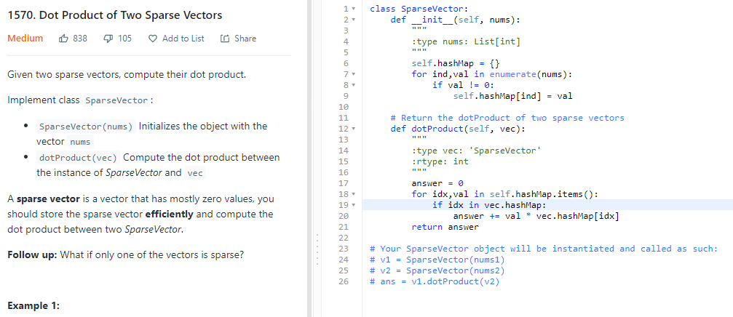

Time: max(O(n),O(v)), v is the number of non-zero items, O(v) is for calculation of dot products

Space: O(L), L is the number of nonzero items

## 1762. Buildings with an Ocean view

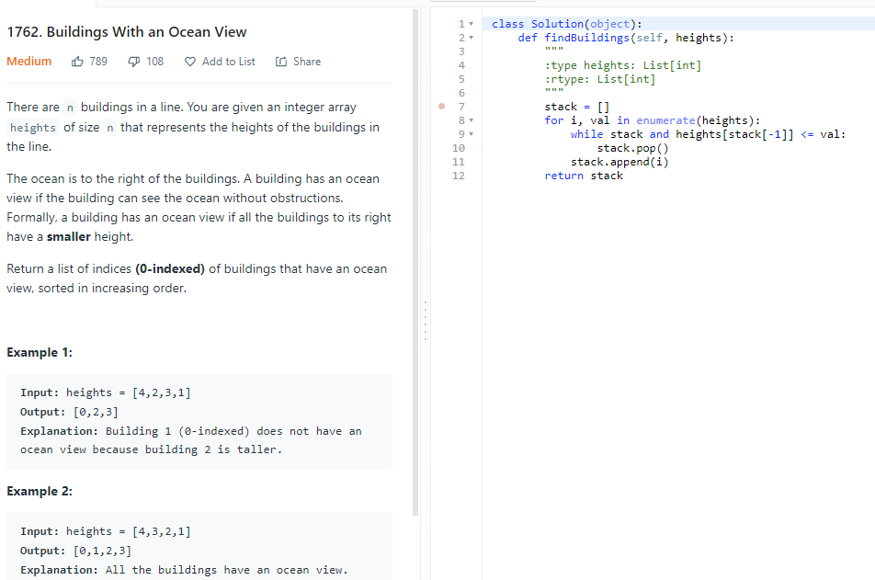

Time: O(n)

Space:O(n)

## 1891. Curring Ribbons

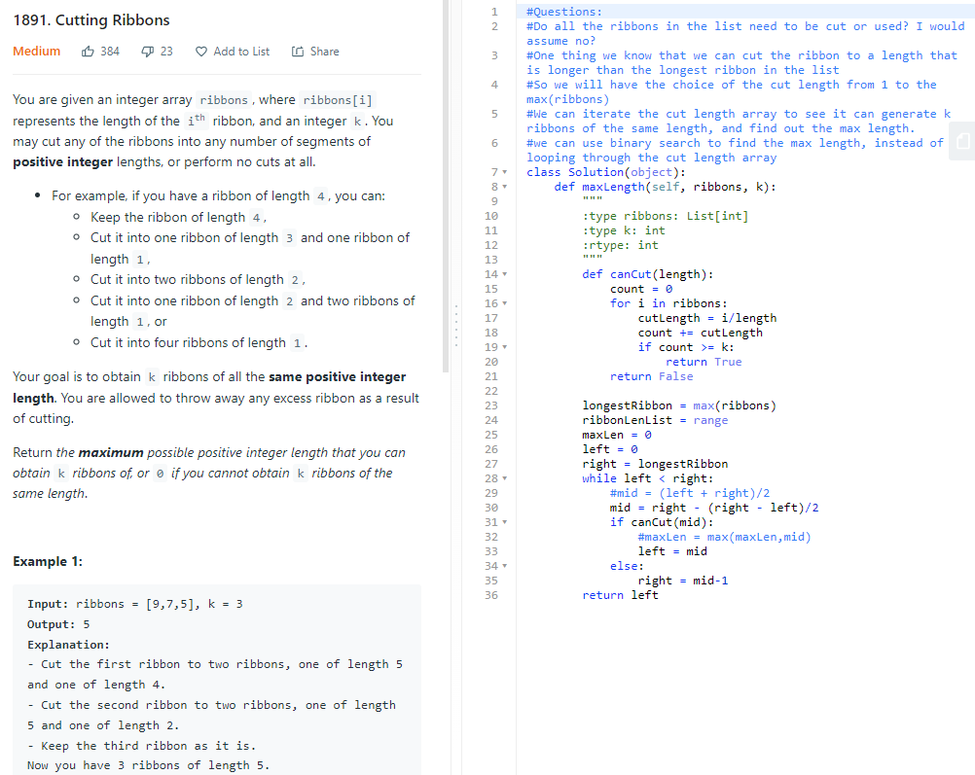

Time:O(logn), space:O(1)

Brute force:

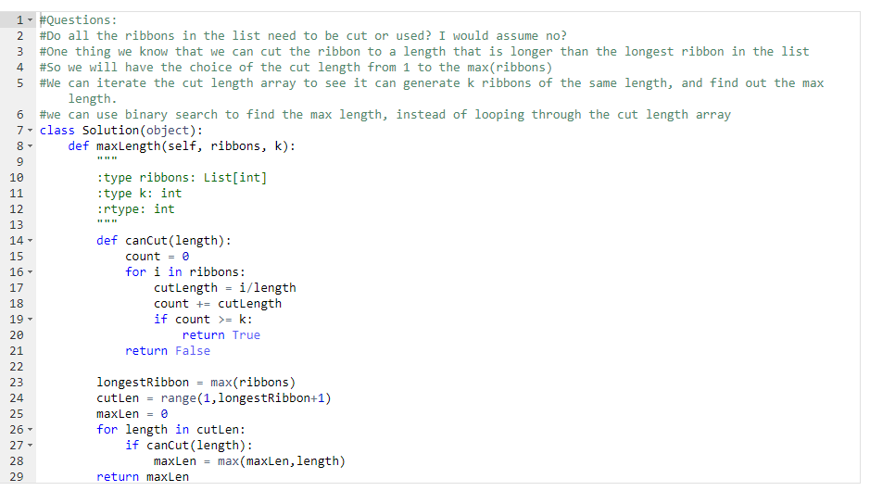

Time O(n2), spaceO(1)

# String

## 953. Verifying an Alien Dictionary

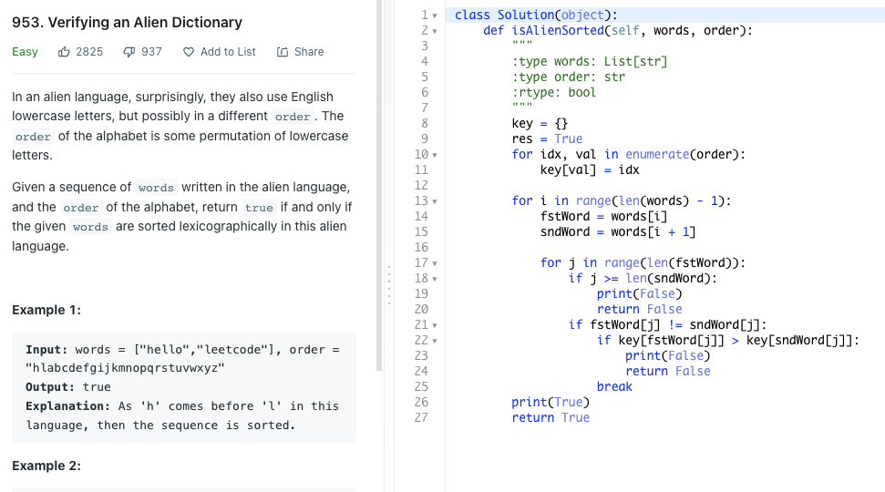

## 249. Group Shifted Strings

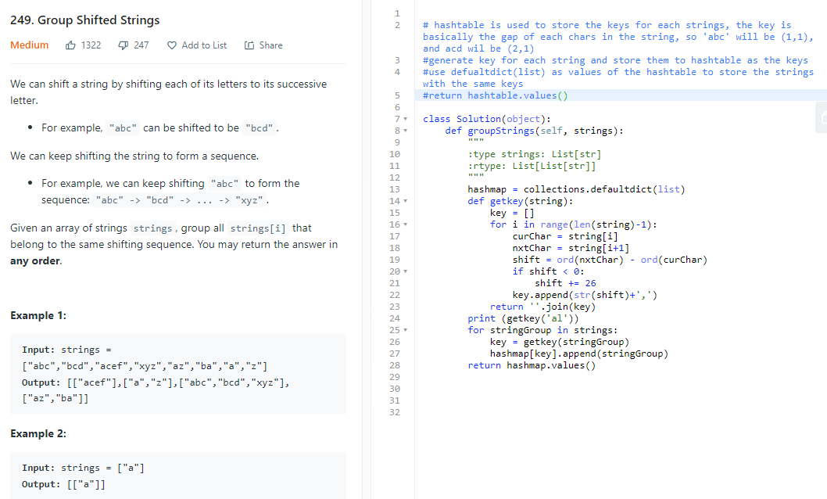

Time:O(n*m), n is the number so strings, m is the number of char in the string

Space: O(n*m), n is the number of strings

## 249. Group Shifted String

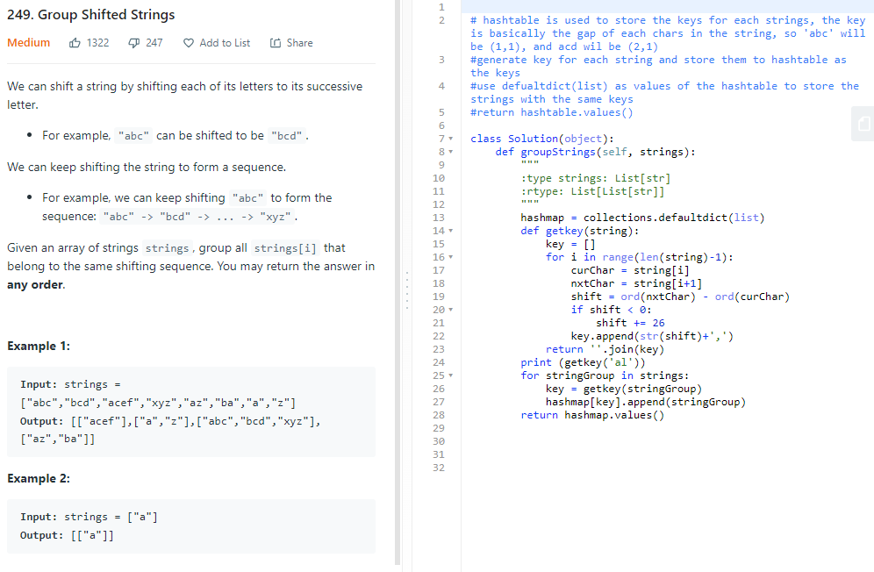

Time:O(n*m), n is the number of strings, m is the max length of a string

Space: O(nm), same idea as above

## 1249. Minimum Remove to Make Valid Parentheses

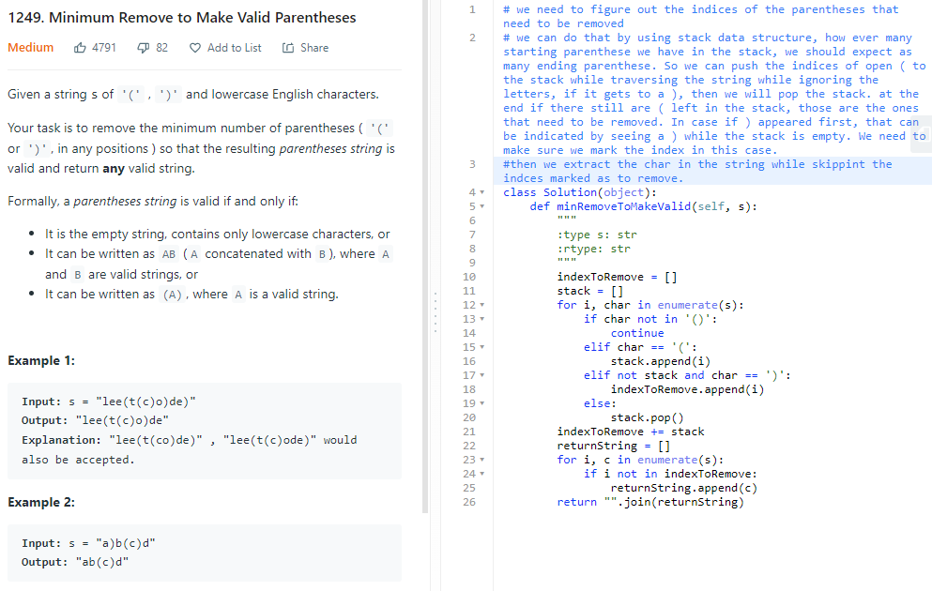

Best solution!!

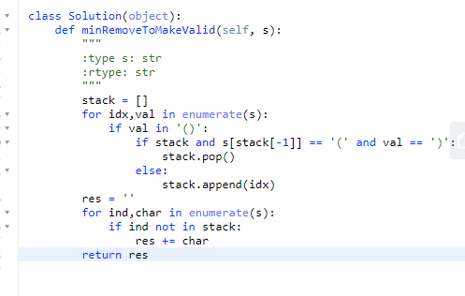

Time: O(n)

Space: O(n)

## 921. Minimum Add to make Parenthese Valid

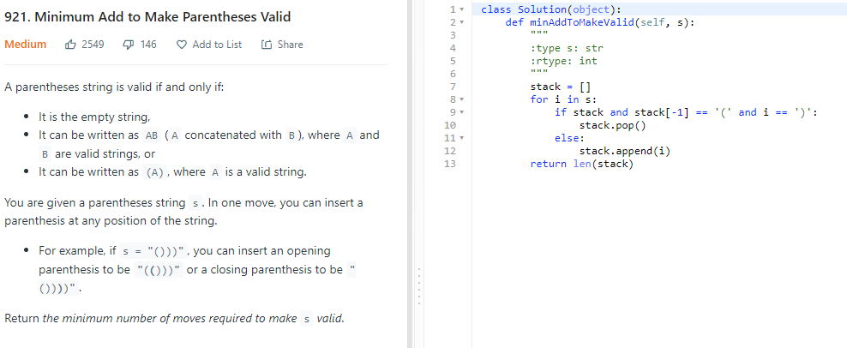

Time: O(n), space O(n)

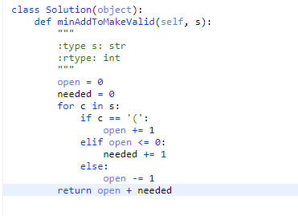

Time:O(n), space:O(1)

## 125. Valid Palindrome

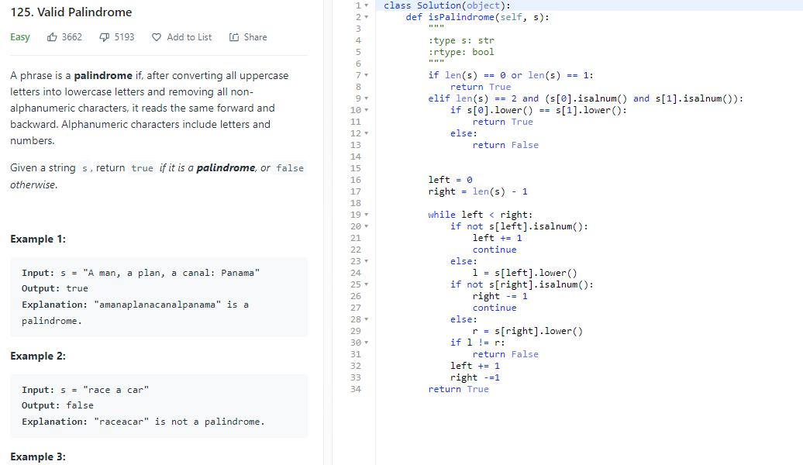

## 680. Valid Palindrome II

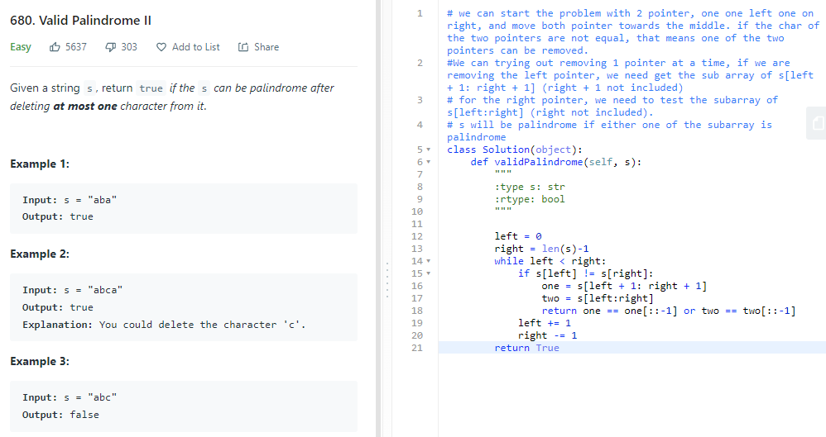

Time: O(n)

Space: O(n) because I’m make copies of the array

## 227. Basic Calculator II

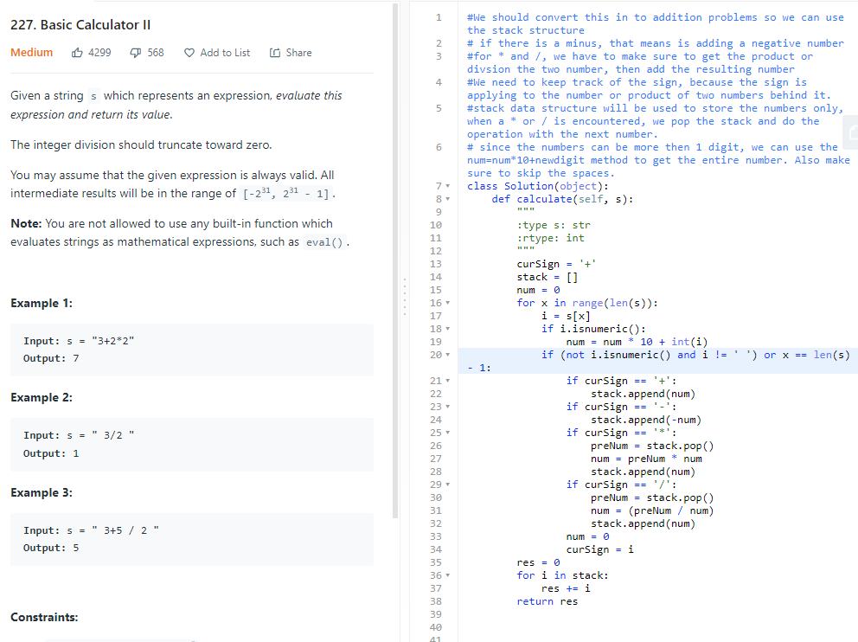

Time: O(n)

Space: O(n), using the stack

## 408. Valid Word Abbreviation

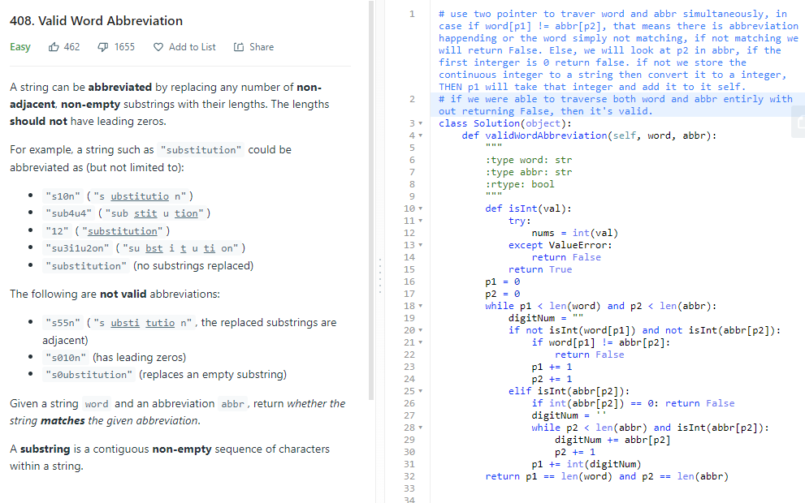

Time: O(N+M), word string and abbr string, Space:O(1)

## 415. Add Strings

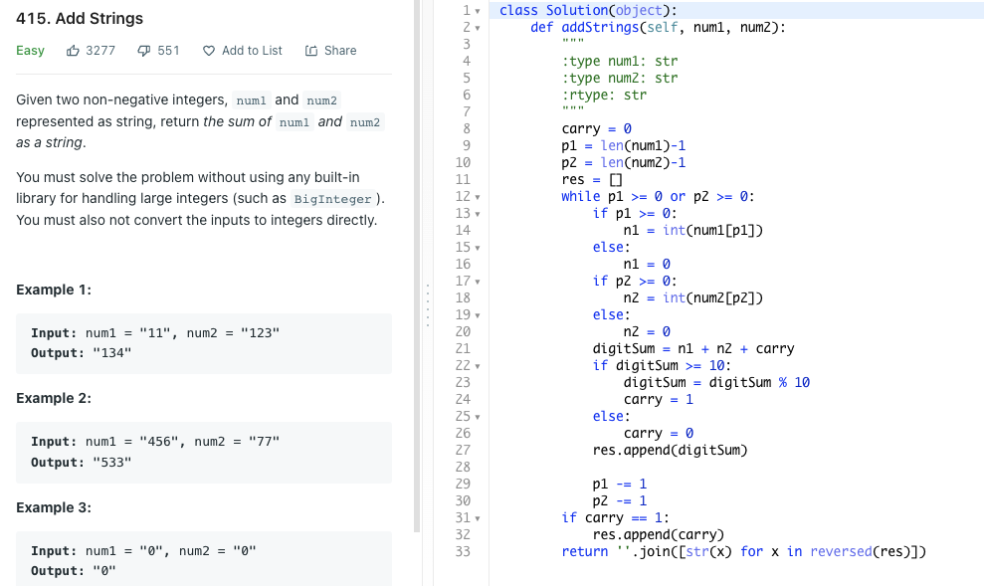

Time: O(n), n is max(len(num1,num2).

Sapce: O(n), n is max(len(num1,num2). Because the returned resulting array

## 791. Custom Sort String

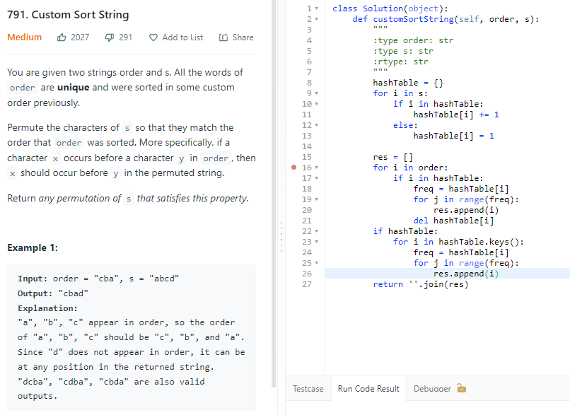

Time: O(len(s)+len(order)), space: O(n), n being the len(s)

## 246. Strobogrammatic Number

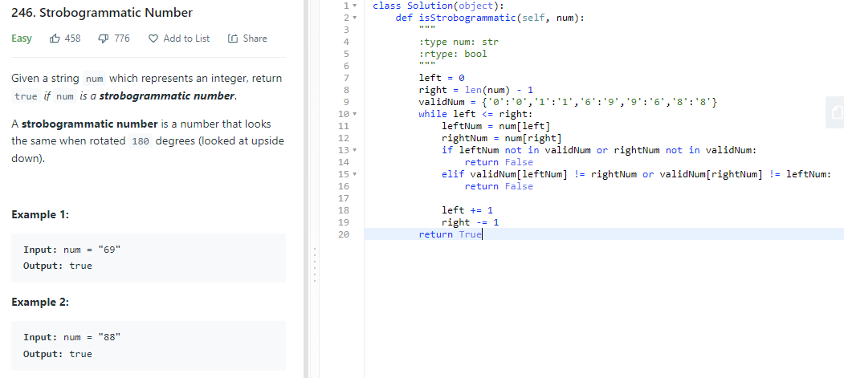

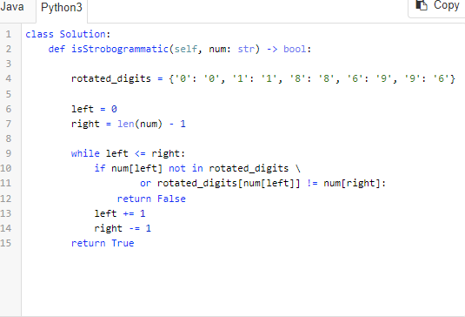

## 636. Exclusive Time of Functions

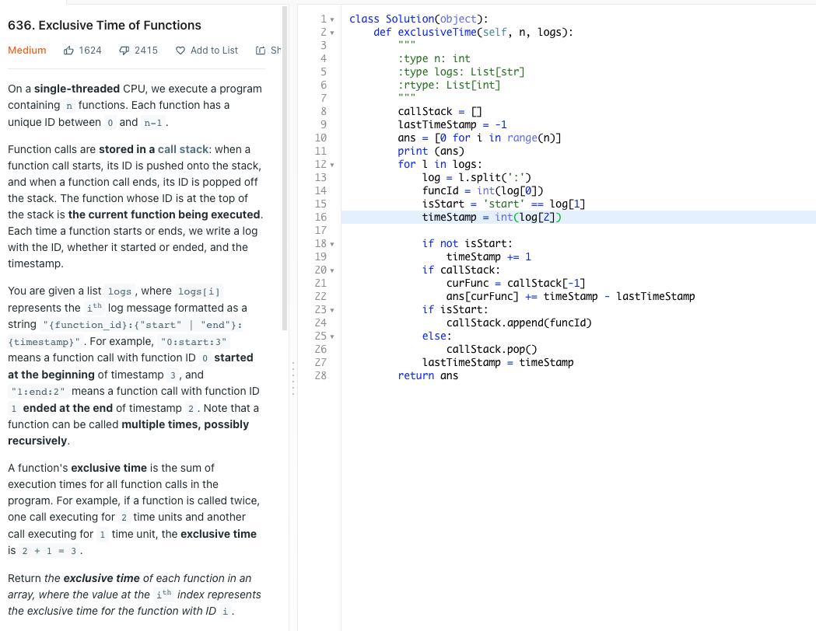

# Binary Trees

## 314. Binary Tree Vertical Order Traversal

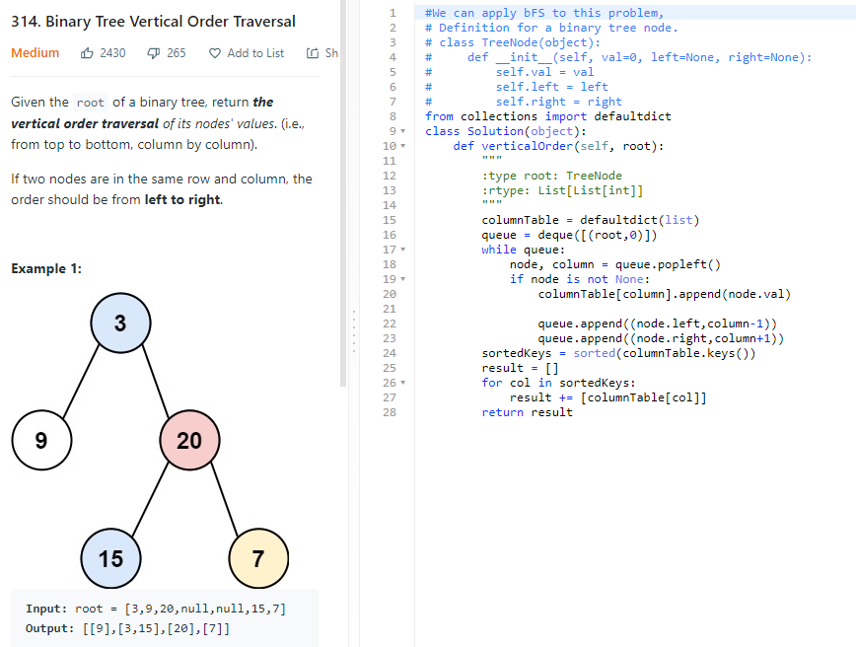

Time: O(n) since we will be visiting all notes, O(nlogn) because of sorting

Space: O(n), think about the hash keys values, the que and the result array

## 1650. Lowest Common Ancestor of a Binary Tree III

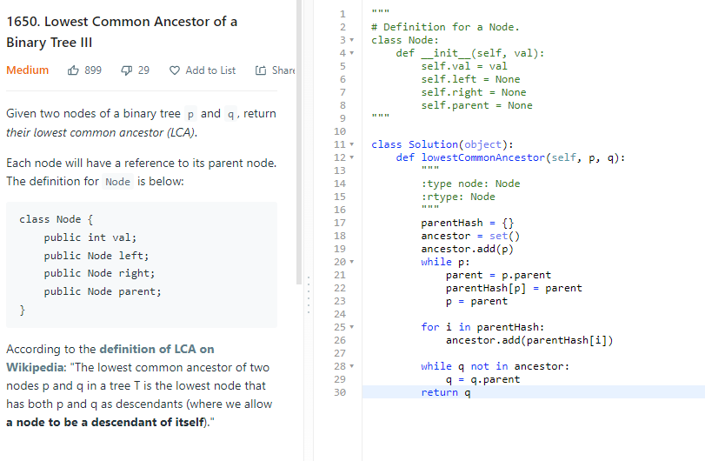

## 938. Range Sum of BST

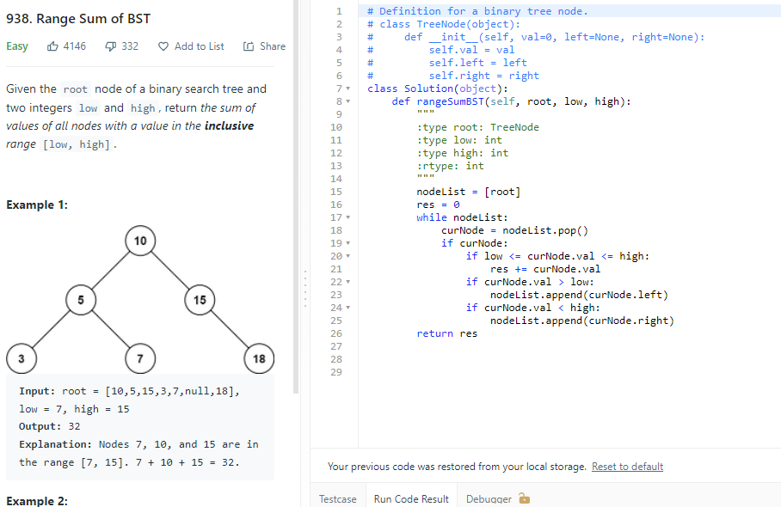

## 236. Lowest Common Ancestor of a Binary Tree

To know the LCA of the two notes, we first have to find out what ancestor do p and q have individually. We can traverse the tree from root node until we find both p and q. and as we were traversing, we will get data on which node is parent or child of which node. We can use a hashTable to do this, the key will be the nodes and values be their parent pointer. We first initialize the hash table with {root: None}, then as we visits the children, their direct parent become the value they correspond to. Once p and q are both found, we can list out all the parents p have in a set, let’s call it parentset, and then we look at q, if q is in the parentset that means q is the LCA. We can keep finding the parents of q using the original hashtable, is p is found to be the parent of q, then p is the LCA, otherwise the LCA is the node at the end of the parentSet.

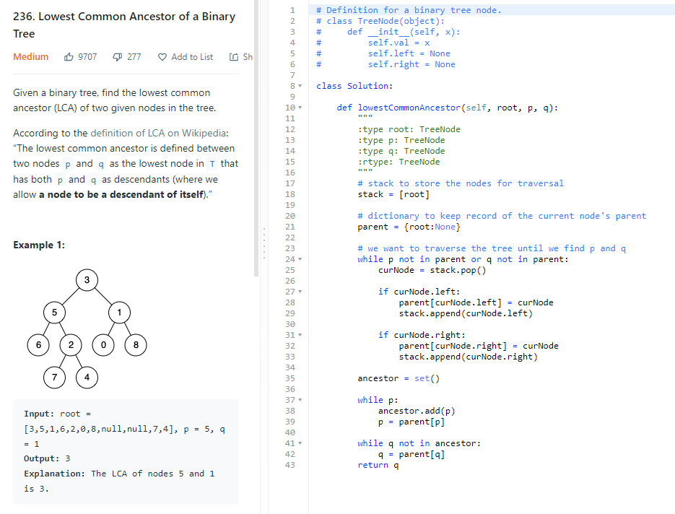

## 199. Binary Tree Right Side View

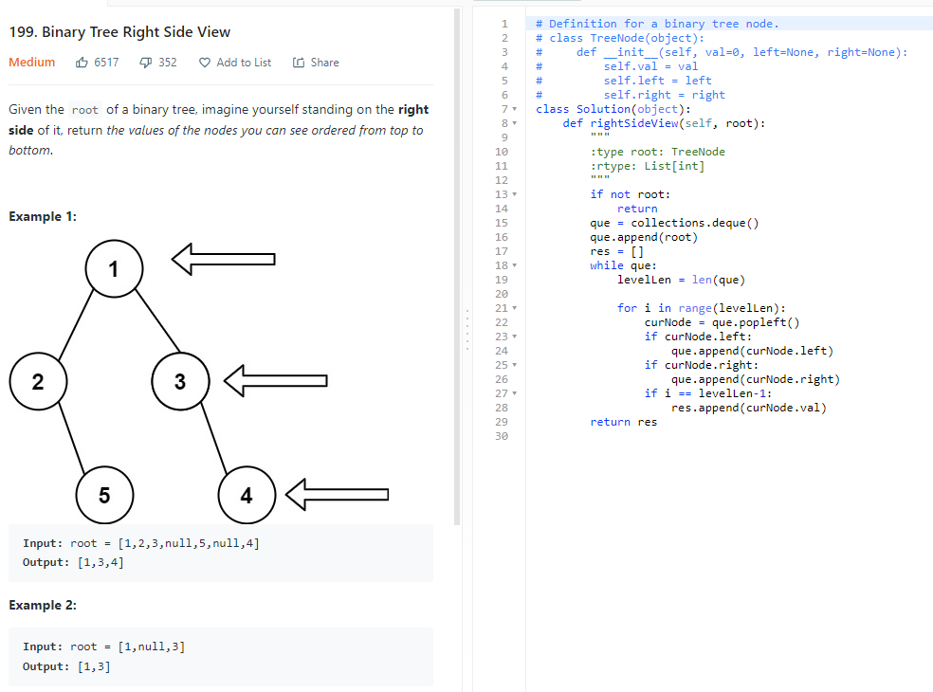

Time: O(n), we may have to traverse all notes

Space: O(width) because of the que, the last level could have N/2 tree nodes

## 543. Diameter of Binary Tree

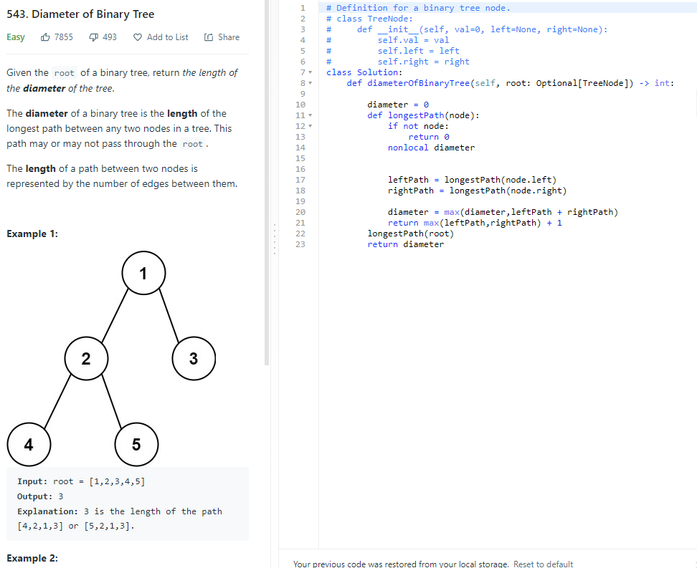

## 270. Closest Binary Search Tree Value

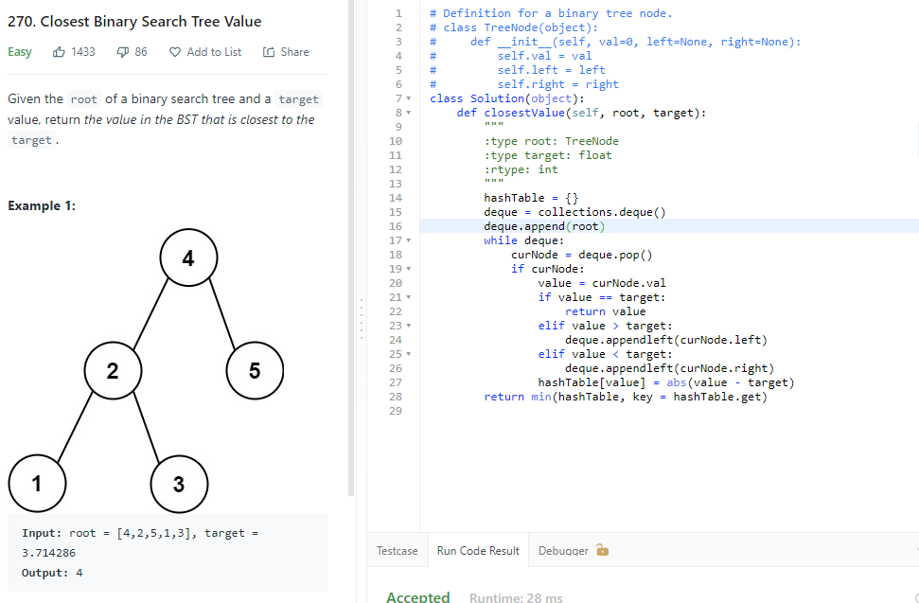

Time: O(n)

Space:O(n) for the hashtable

## 426. Convert Binary Search Tree to Sorted Doubly Linked List

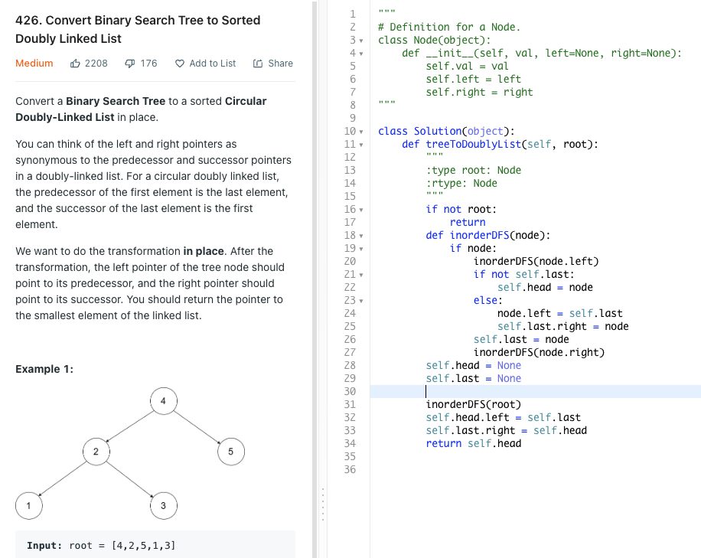

Time: O(n), space: O(n)

## 173. Binary Search Tree Iterator

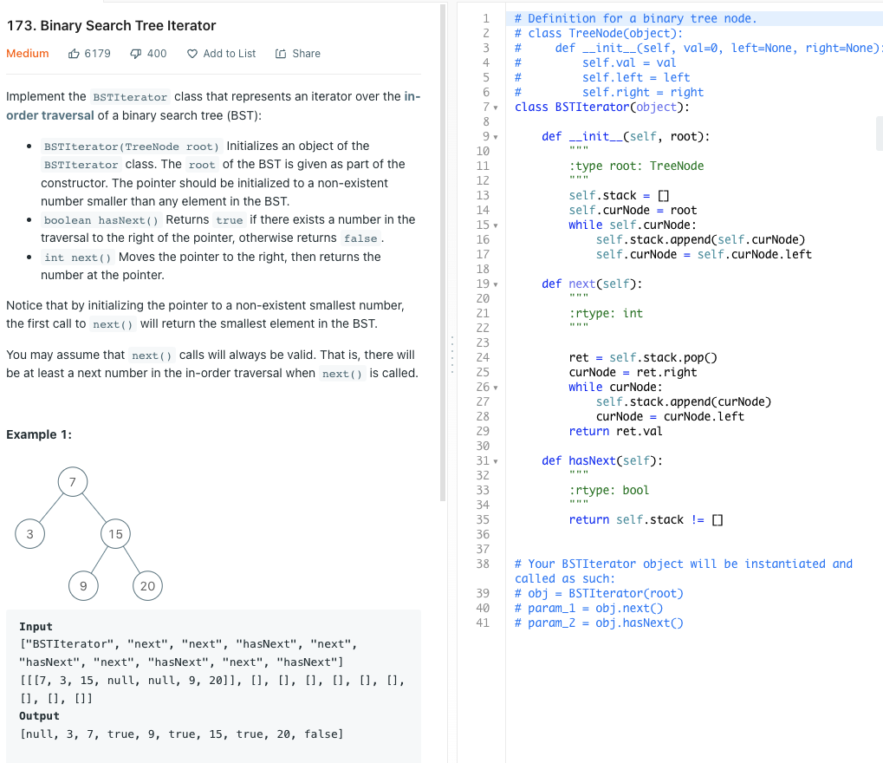

Time: O(1) and O(n) in worse case due to we have to find the left most node

Space:O(n), n is the # of nodes I the tree

# Depth First Search and Breath First Search

## 721. Accounts Merge

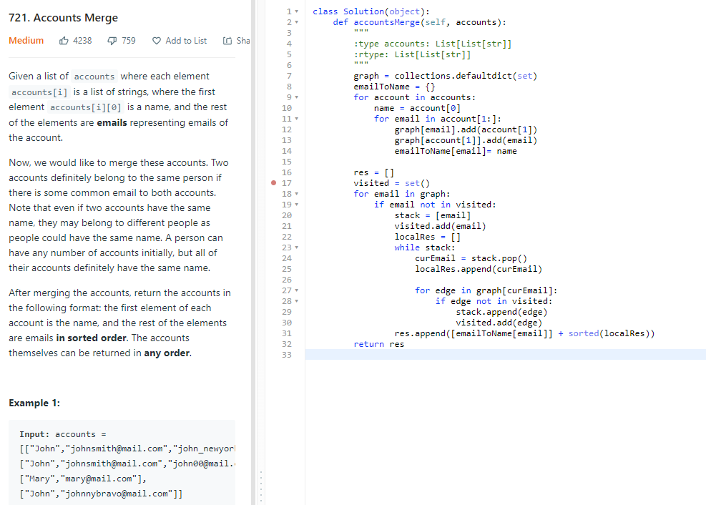

# Structure Design and Linked List

## 146. LRU Cache

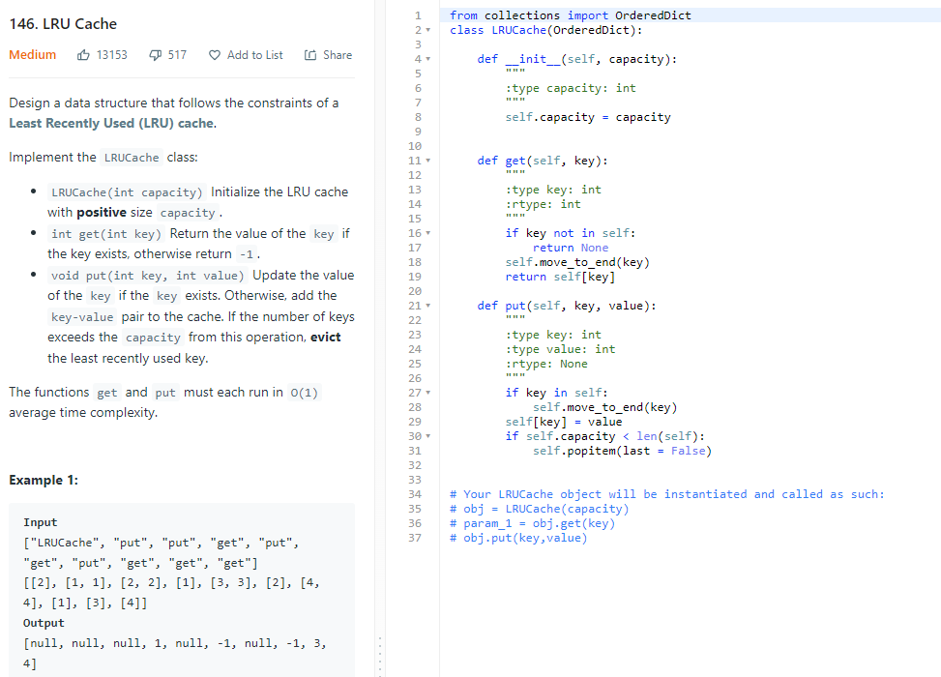

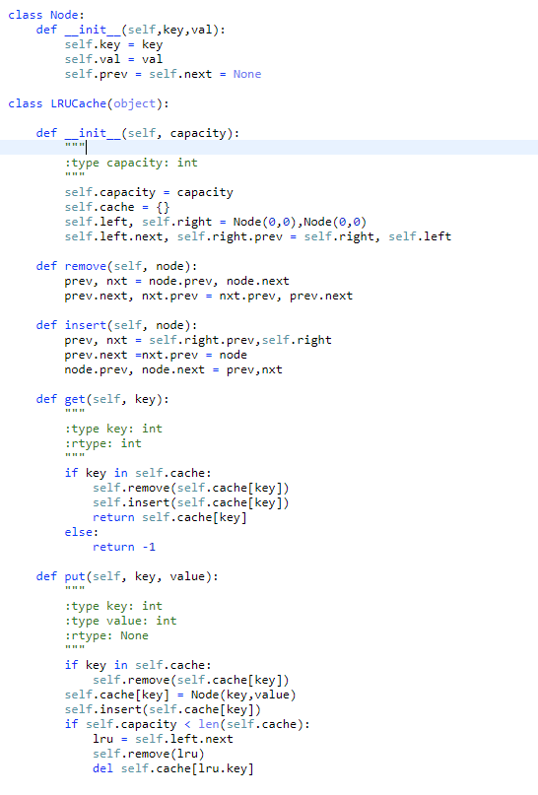

## 234. Palindrome Linked List

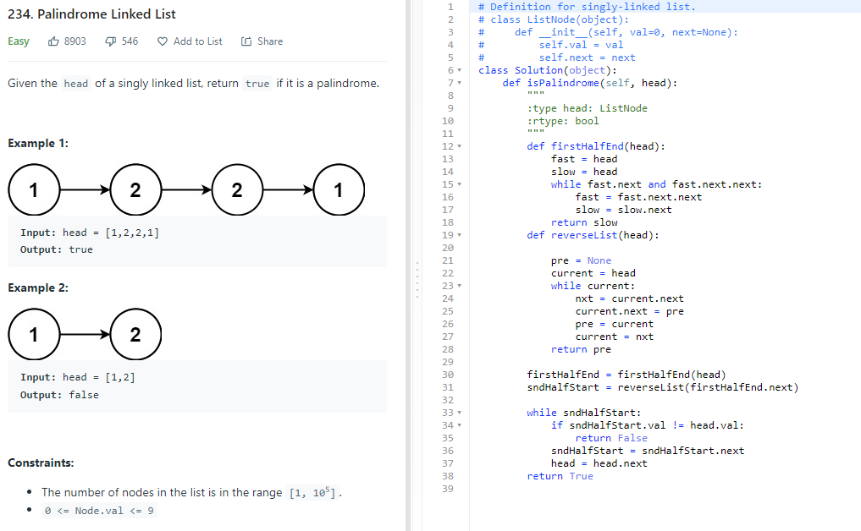

## 346. Moving Average from Data Stream

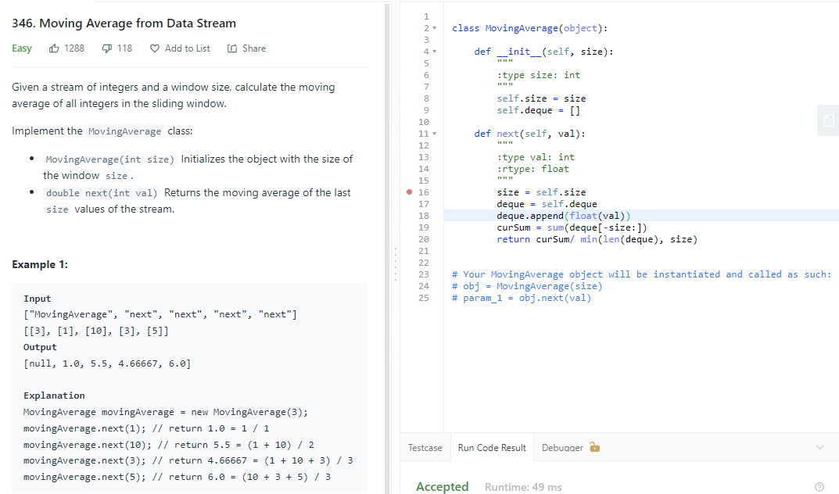

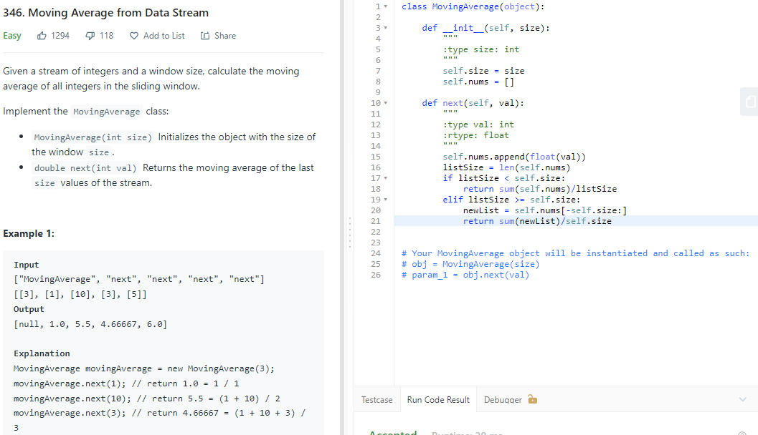

Time O(n)

Space: O(n)

## 1570. Dot product of two sparse vectors

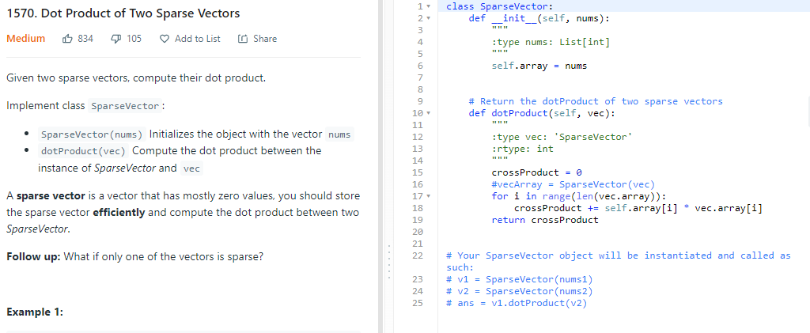

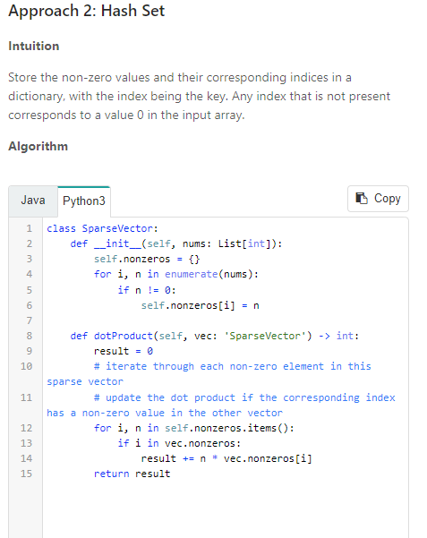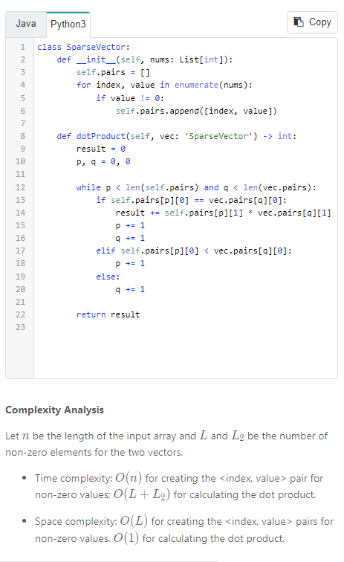

## 138. Copy List with Random Pointer

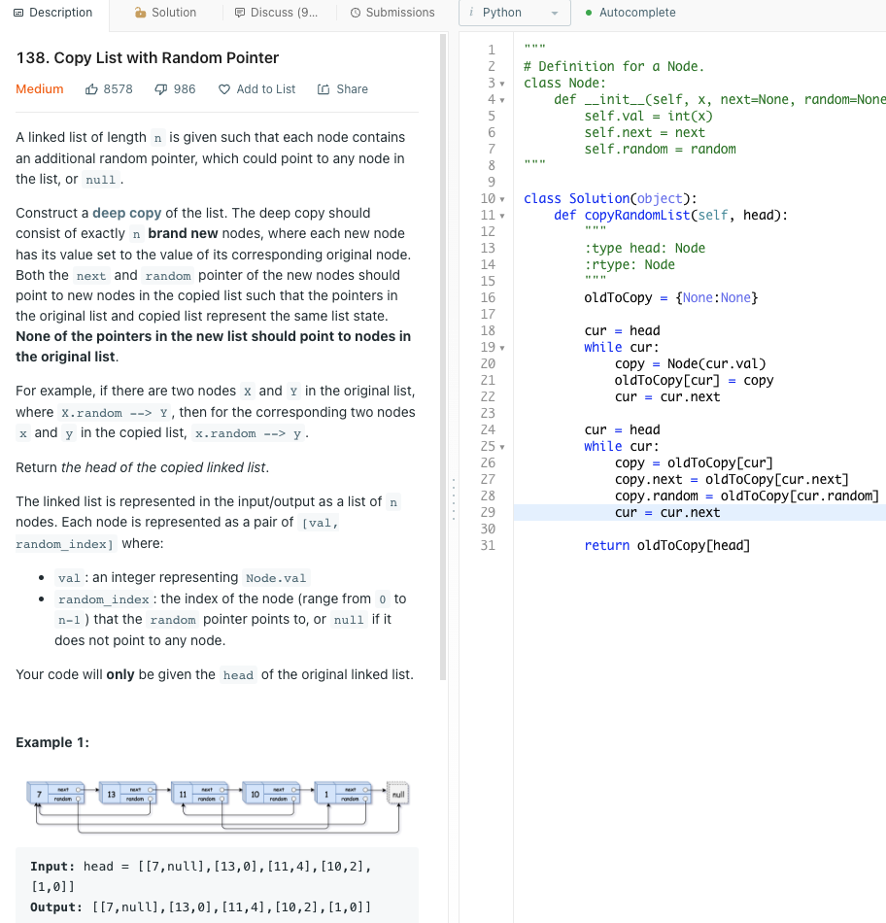

## 708. Insert into a Sorted Circular Linked List

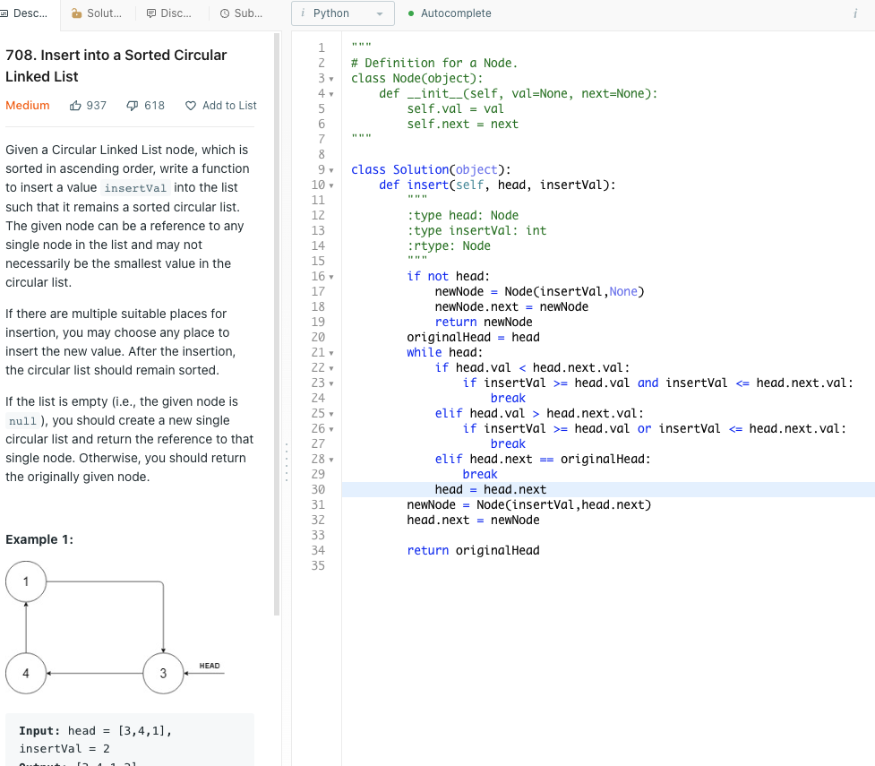

## 528. Random Pick with Weight

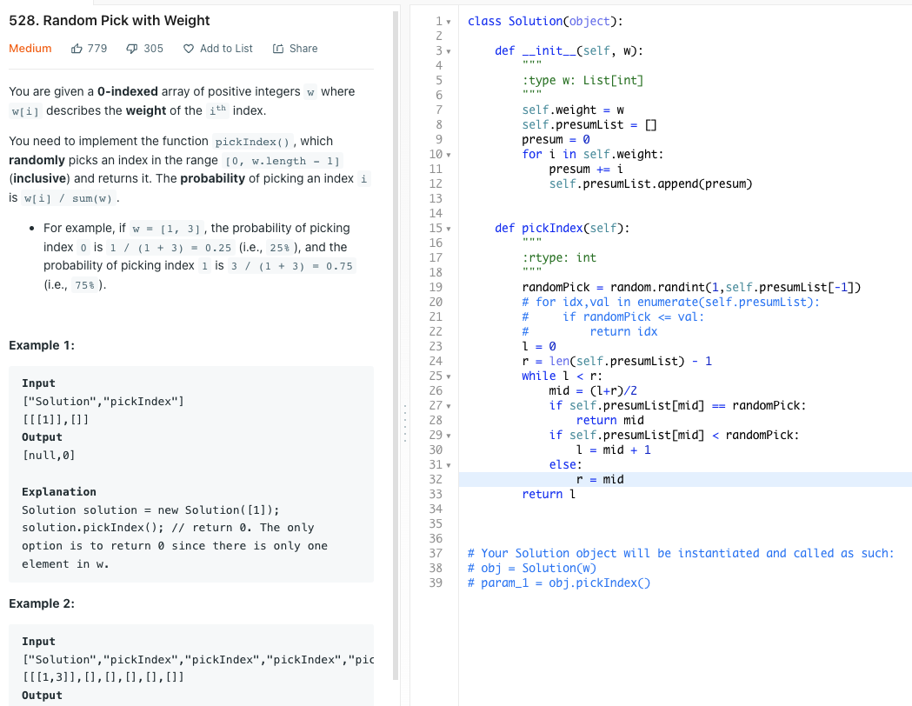

Time: O(n) for constructor O(logn) for binary search

Space: O(n) for the constructor

# Matrix

## 766. Teoplitz Matrix

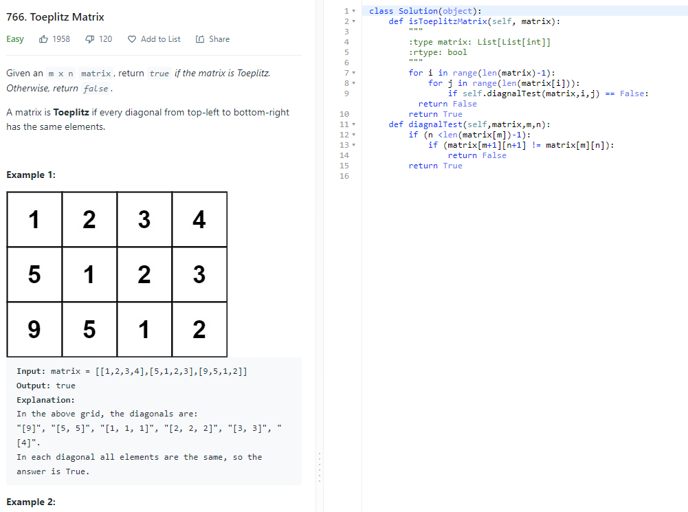

Time: O(mn), m and n is the number or rows and columns

Space, O(m+n)

## 498. Diagonal Traverse

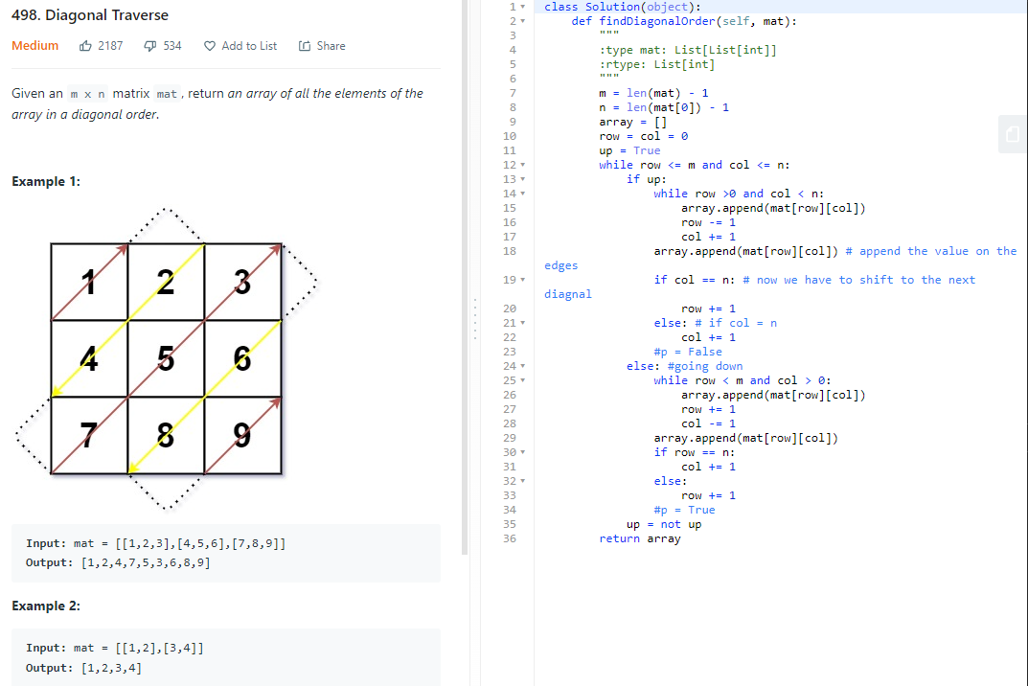

## 1091. Shortest Path in Binary Matrix

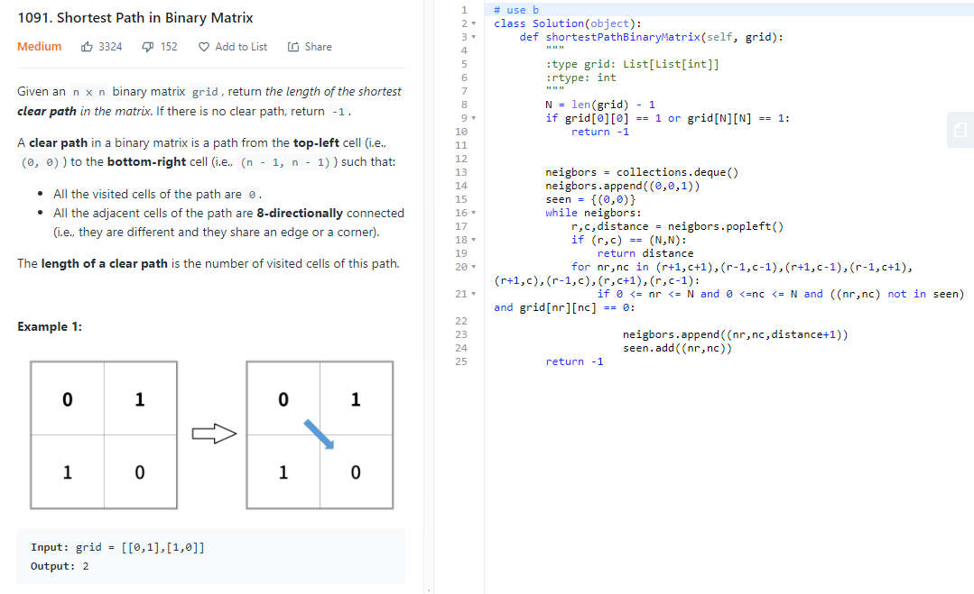

Time:O(n)

Space:O(1)

# Recursion:

## 339. Nested List Weight Sum

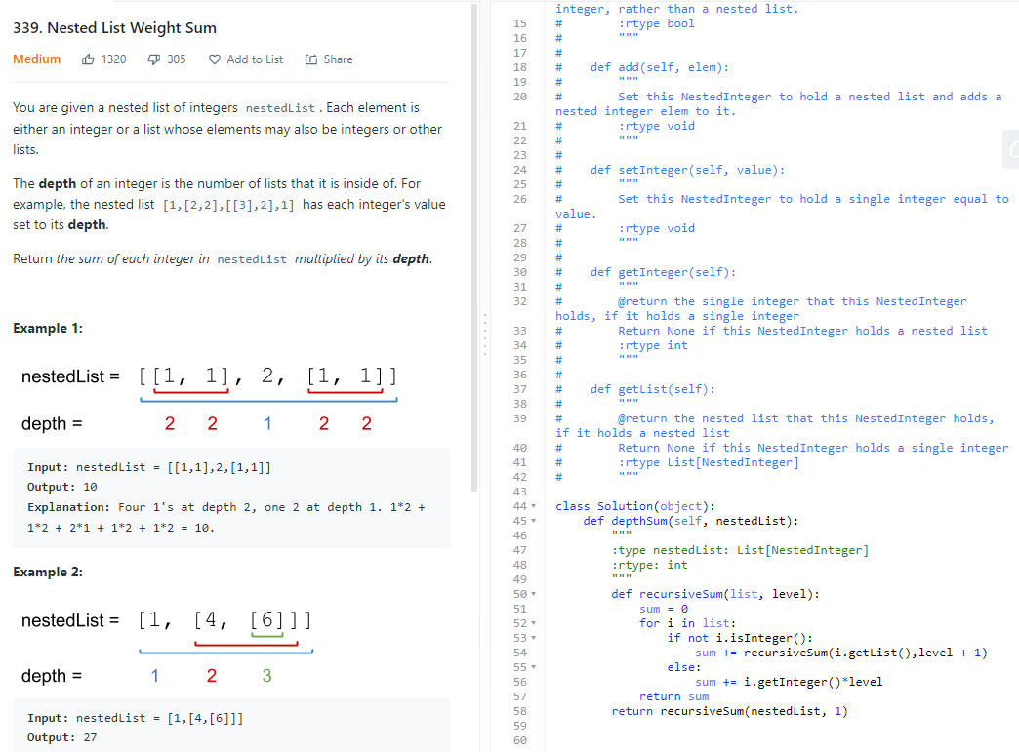

Time: O(2N), 1 N is the recursive call, the other N is the iteration inside the recursive call

Space: O(N), N being the number of recursive calls

## 50. Pow(x,n)

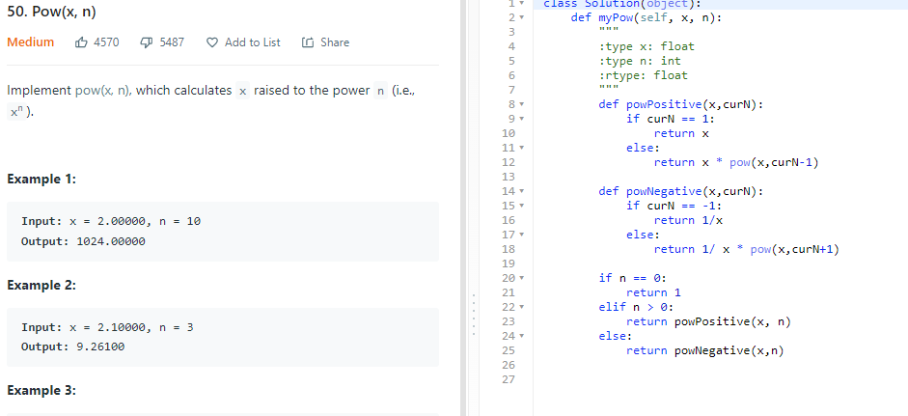

Time: O(n), space:O(1)

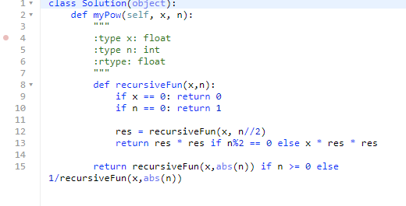

Time: O(logn), space: O(logn)